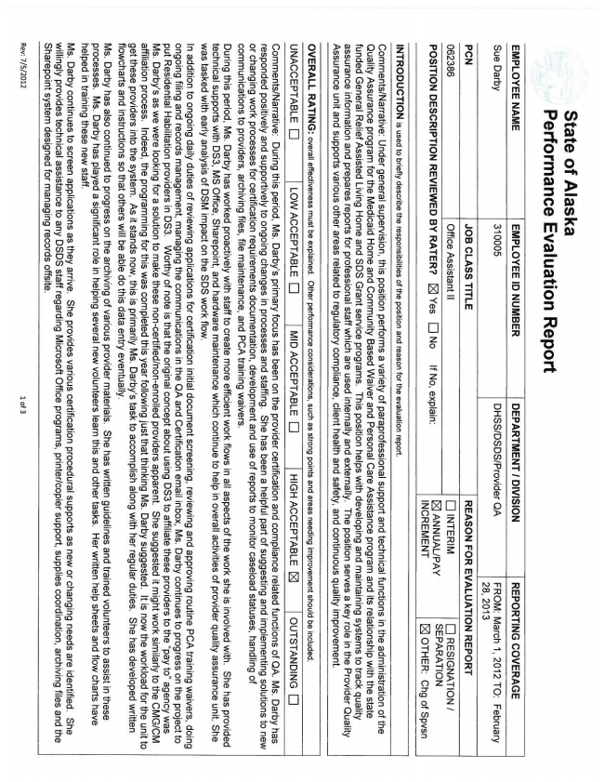

State of Alas ka Performance Evaluation Report

EMPLOYEE NAME | EMPLOYEE ID NUMBER i DEPARTMENT! DIVISiON l REPORTiNG COVERAGE Sue Darby | 310005 | DHSSIDSDSJProvíder QA | FROM: March 1, 2012 TO: February 2B, 2013 PON | JOB CLASS TfTLE | REASON FOR EVALUATION REPORT 062386 | Assistam || | [j 1NTER2M ì D „TF-MH? E@ ANNUAUPAY | SEPARATION

POSITìON DESCRìPTION REVIEWED BY RATER? QQ Yes E] No if No,

INCREMENT | E OTHER: Chg of Spvsn

INTRODUCTION is used to briefly describe the responsibitities of the position and reason for the evaluation report.

CommentsiNarrative: Under generai supervision, this position performs a varietyr of paraprofessional support and technical functions in the administration of the Quaìity Assurance program for the Medicaid Home and Community Based Waiver and Personal Care Assistance program and its relationship with the state funded General Relief Assisted Living Home and SDS Grant service programs. This position with developing and maintaining systems to track quaìity assurance information and prepares reports for professional staff which are used internally and externaliy. The position serves a key role in the Provider Quality Assurance unit and supports various other areas reiated to reguiatory compilance, oiient heaith and safety, and continuous quaiity improvement,

ÓVERALL RATING: everaíl effectiveness musi be explained. Other perfomance considerations, such as strong points and areas needing improvement should be iraeimtied`

UNACCEPTABLE III LOW ACCEPTABLE D | MID ACCEPTABLE CI | HIGH ACCEPTABLE IZ | OUTSTANDING

Commentstarrative: During this period, Ms. Darby’s primary focus has been on the provider certification and compliance related functions of QA. Ms. Darby has responded positively and supportiver to ongoing changes in processes and staffing, She has been a helpful part of suggesting and implementing solutions to new or changing work processes for oertiñcation requirements documentation, development and use of reports to monitor caseload statuses, handling of communications to providers, archiving tilesI tite maintenance, and PCA training waivers,

During this period, Ms. Darby has Worked proactiver with to create more efficient work flows in all aspects of work she is involved with. She has provided technical supports with DSS, MS Office, Sharepoint, and hardware maintenance which continue to help in overall activities of provider quality assurance unit. She was tasked with early analysis of DSM impact on the SDS work flow.

tn addition to ongoing daity duties of reviewing applications for certification initial document screening, reviewing and approving routine PCA training waivers, doing ongoing filing and records management, managing the communications in the QA and Certification email inbox, Ms. Darby continues to progress on the project to put Residential Habilitation providers in D83. Worthyr of note is that the original concept about using D83 to affiliate these providers to the “pay to” agency was Ms, Darbv’s as we were looking for a solution to make these non-oertifiedfnon-enrolled providers apparent. She suggested it might work similarìy to the CMGICM aŕŕiiiation process. indeed, the programming for this was completed this year following just that thinking Ms. Darby suggested. it is now the workload for the unit to get these providers into the system. As it stands now, this is primarily Ms. Darby’s task to accomplish along with her regular duties. She has developed written fiowoharts and instructions so that others wili be able do this data entr)I eventually.

Ms Darby has also continued to progress on the archiving of various provider materials. She has written guidelines and trained volunteers to assist in these processes. Ms, Darby has played a significant role in helping several new volunteers learn this and other tasks. Her written help sheets and flow charts have helped in training these new

Ms. Darby continues to screen applications as they arrive. She provides various certification procedural supports as new or changing needs are identified She willingly provides technical assistance to anyr DSDS staff regarding Microsoft Office programs, printerfcopier support, supplies coordination, archiving files and the Sharepoint system designed for managing records offsite.

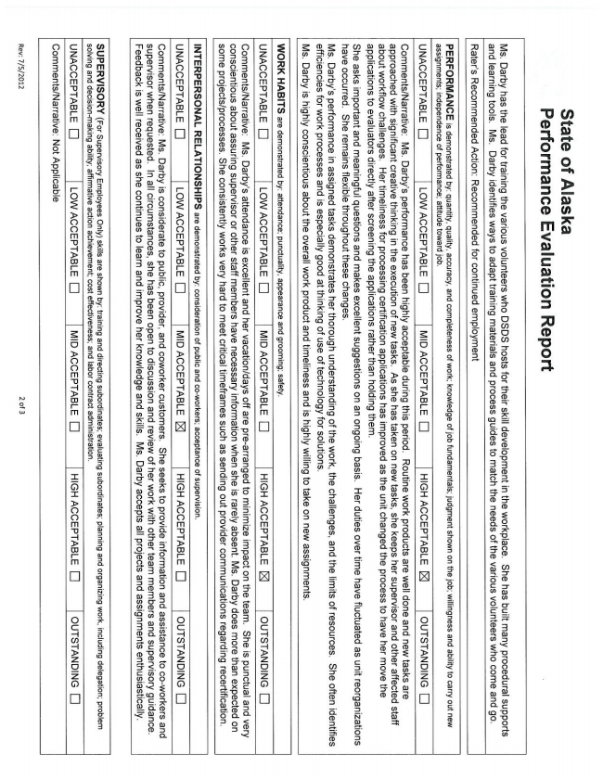

State of Alaska Performance Evaluation Report

Nts. Darby has the lead for training the various volunteers who DSDS hosts for their skill development in the workplace. She has built many procedural supports and learning tools. Ms. Darby identifies ways to adapt training materials and process guides to match the needs of the various volunteers who come and go.

Rater's Recommended Action: Recommended for continued employment

PERFORMANCE is demonstrated by: quantity, quality, accuracy, and completeness of work: knowledge of job fundamentals; judgment shown on the job: willingness and ability to carry out new assignments; independence of perfomance; attitude toward job.

UNACCEPTABLE E] I LOW ACCEPTABLE D MID ACCEPTABLE [ì "HlGH AcCäPTABLE E ioUTSTANDiNG lj

CommentslNarrative: lvls. Darbv's performance has been highly acceptable during this period` Routine work products are well done and new tasks are approached with significant creative thinking in the execution of new tasks. As she has taken on new tasks, she keeps her supervisor and other affected staff about workflow challenges. Her timeliness for processing certification applications has improved as Ithe unit changed the process to have her move the applications to evaluators directly after screening the applications rather than holding them,

She asks important and meaningful questêons and makes excellent suggesîlons on an ongoing basis. Her duties overtime have fluctuated as unil reorganizations have occurred. She remains flexible throughout these changes`

Ms. Darby's performance in assigned tasks demonstrates her thorough understanding of the work, the ohelíenges, and the limits of resources. She often identiñes efficiencies for work processes and is especiaiiy good at thinking of use of technology for solutions,

Ms. Darby is highly conscientious about the overall work product and timeliness and is highiy willing to take on new assignments.

WORK HABQTS are demonstrated by: attendance; punctuality, appearance and grooming: safety.

UNACCEPTABLE i] Low ACCEPTABLE E i TMmACCEPTABLE D HIGH ACCEPTABLE E i ouîsTANDiNG I]

Comments/’Narrative Ms. Darby's attendance is excellent and her vacationldays off are pre»arranged to minimize impact on the team. She is punctual and very conscientious about assuring supervisor or other stattc members have necessary information when she is rarer absent, Ms. Darby more than expected on some projectsfprocesses, She consistently works very hard to meet critical timeframes such as sending out provider communications regarding recertitîcation.

INTERPERSONAL RELATIONSHIPS are demonstrated by: consideration of public and crc-workers: acceptance of supervision.

UNACCEPTABLE [I | LOWACCEPTABLE C] | MIDACCEPTABLE LXI | HIGH ACCEPTABLE [t rouTsTANDiNG ij

Commentstarrative: Ms. Darby is considerate to public, provider, and coworker customers. She Seeks to provide information and assistance to co-vvorkers and supervisor when requested. In all circumstances, she has been open to discussion and review of her work with other team members and supervisory guidance. Feedback is well received as she continues to learn and improve her knowledge and skills. Ms. Darby accepts all projects and assignments enthusiastically.

SUPERVISORY (For Supervisory Employees Only) skills are shown by: training and directing subordinates; evaluating subordinates; planning and organizing vvorkr including delegation; problem solving and decisionmaking ability; affirmative action achievement; Cost effectiveness; and labor contract administration.

UNACCEPTABLE El | LOW ACCEPTABLE E | MID ACCEPTABLE D | HIGH ACCEPTABLE [l I OUTSTANDING tj

Commentstarrative; Not Appticabie

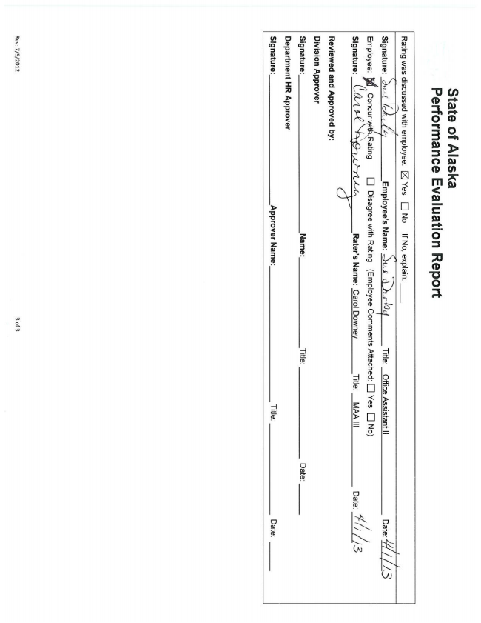

State of Alaska Performance Evaluation Report

Rating was discussed with employee: [XI Yes [I No If No, explain; _

Title: Office Assistant ||

Employee; {,IConcur v Rating lj Disagree with Rating (Employee Comments Attechedi E Yes D No) i n

Signature: LLL/W( Raters Name: Carol Downey Tine: MAA

Reviewed and Approved by: Division Approver

Signature: Name: Title: Date; Department HR Approver

Signature: Approver Name: Titìe:

Date:

Rev: TIS/2012 3 of 3